Defining Classes Labs – Part 1

This is an individual lab.

Read the attached Defining classes lab.

Your tasks:

1. Create a class diagram to support the case study and Systems Use Case Specifications

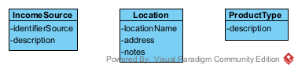

1. Create object level sequence diagrams – one for each of the Query use cases. (3 object level sequence diagrams)

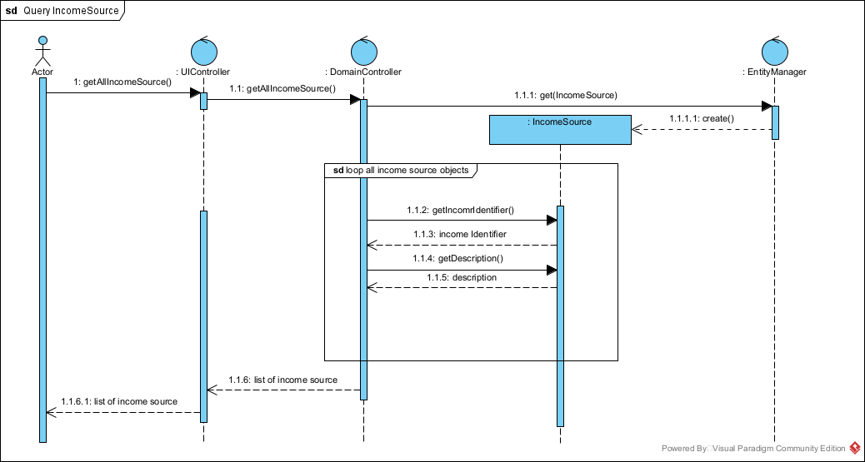

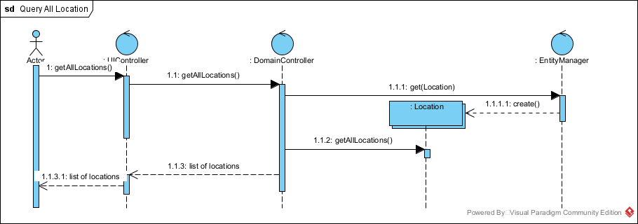

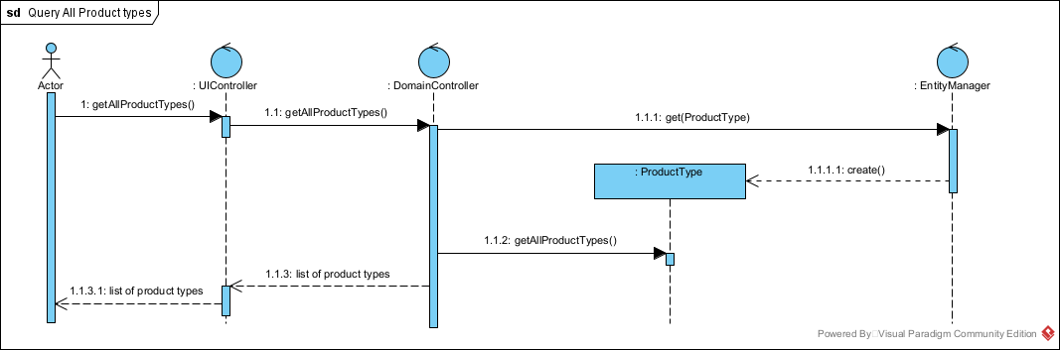

Copy and paste your diagrams in to a .docx compatible file. Submit your .docx file along with your .vpp (visual paradigm) file.